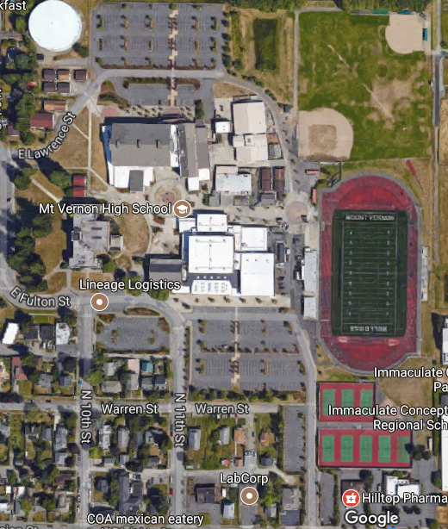

Field #3

Field #4

Field #5

Field #6

Field #1

Field #2

Parking

Parking

Parking